|  |
| --- |
| Circle Language Spec: Commands |

## Executable Command Object Redirection

An executable command, that redirects to another executable command, is a reference to a command that could run, or could be running. Say you run the command on a site and you want to navigate away from the site, but keep a reference to it in your user object, that points to a process running on a site somewhere, and take along the reference anywhere you go on the internet.

Executable command object redirection is less common than inactive command object redirection.

You can also object redirect an executable command to an inactive command. If the final target of the object redirections is an inactive command, then you can not run that unexecutable command object through an active reference to it. It is kind of pointless to point to an inactive command object through an executable command reference, so it is very uncommon.

### In a Diagram

The concept of execution object redirection is explained in the article *Execution Object Redirection*. The current article explains its expression in a diagram.

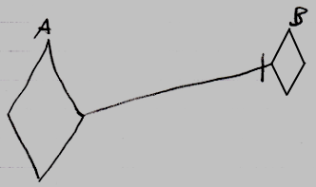

Active command symbol A is a diamond shape, because it is an *active* command. Active command symbol A redirects its object to the active command symbol B. The redirection from command A to command B is displayed as a solid line, which is an object line. This makes symbol A a reference to an execution running elsewhere.

You can also have an active reference to an inactive command:

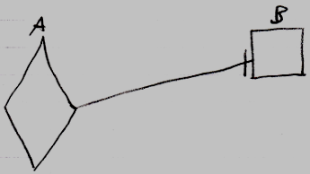

But this situation is very uncommon. You can not run command B through symbol A, because an inactive command object can never be run.